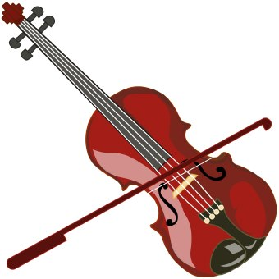

How to care for the violin:
Safest place is in the case, unless you are playing it!
When unpacking:
- Take violin out and put the sponge in-between the rubber bands or put the shoulder rest on
- Tighten bow (rosin if you have it – I will rosin bows every week in class)
When playing violin:
- Still do the 1-2-3-4 please! This gets the violin on the shoulder
- Get good bow hold
- Pinky in the pinkly nest and thumb on the silver tab under the frog
- Place bow at the start sticker (probably green)
- Always bow down first
- Bow only on the E string for now

What to practice/play
- Everything on the What we did today sheet !

Packing up the violin
- Take sponge out (leave rubber bands on violin) or take shoulder rest off
- Put sponge or shoulder rest away
- Open the Velcro seatbelt and place violin in the spot and close the Velcro seatbelt
- Loosen bow
- Place bow in case (tip goes in the cave) click knob so it secures bow in place
- Place cloth on top of violin
- Zip up both zippers on case

